<!--This file created 2:29 PM 10/29/97 by Claris Home Page version 2.0-->9.5 Project
Predator-Prey and Implicit Solution Curves

We illustrate here the plotting of implicit solution curves for the predator-prey system

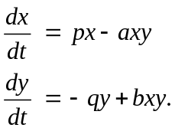 (1)

The implicit general solution given in the text is

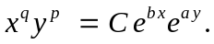 (2)

With the coefficient values 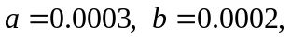 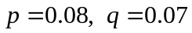 and with initial populations of 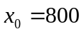 rabbits and 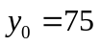 foxes, we find that the value of the arbitrary constant in (2) is 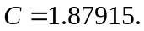 So we want to graph the equation

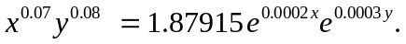 (3)

Using a Graphing Calculator

To plot the solution curve in (3) using a TI-89/92+ graphing calculator, we first select the 3D graph mode in the MODE menu:

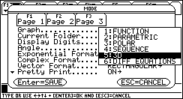

Then we enter our equation 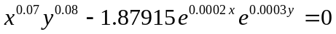 in the Y= editor:

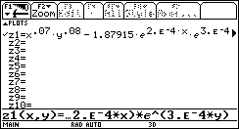

Then we select the CONTOUR LEVELS style in the GRAPH FORMATS dialogue box that is obtained by pressing ♦F:

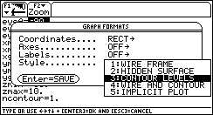

With the WINDOW settings

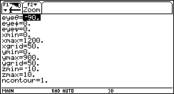

specifying that only a single contour be drawn, we see the implicit solution curve

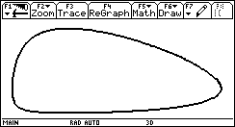

when we press GRAPH. We can press F3 to trace the contour to locate approximately the high point.

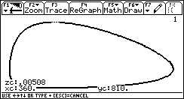

Here we have moved the trace cursor to the apparent high point, and it looks like (360, 810). You could zoom in closer to this high point — by changing carefully the miminum and maximum values of x and y in the WINDOW settings — to see that it's actually (350,820). However, beware that contour plotting evaluation times are quite long with a graphing calculator, so you must plan your plots carefully to avoid excessive work and waiting.

Using Maple

First we load the plotting package

with(plots):

the desired parameter values

p := 0.08; q := 0.07;
a := 0.0003; b := 0.0002;
c := 1.87915;

and our implicit solution equation in the form

z := (x^q)*(y^p) - c*exp(b*x)*exp(a*y);

Then we need only enter the command

contourplot(z, x=0..1200, y=0..900,
grid=[50,50], contours=[0] );

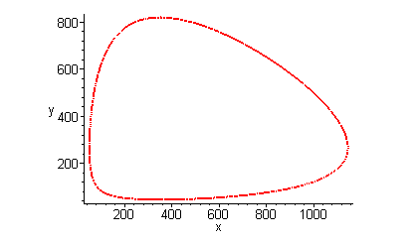
to see the solution curve. To zoom in on the high point on the graph, we enter

contourplot(z, x=345..355, y=819.85,,819.95,
grid=[50,50], contours=[0] );

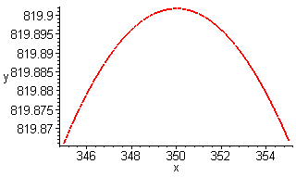

and conclude that the high point has approximate coordinates 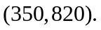

Using Mathematica

First we load the implicit plotting package

<< Graphics`ImplicitPlot`

the desired parameter values

p = 0.08; q = 0.07;
a = 0.0003; b = 0.0002;
c = 1.87915;

and our implicit solution equation

eq = x^q y^p == c E^(b x) E^(a y);

Then we need only enter the command

ImplicitPlot[eq, {x, 0, 1200}, {y,0,900},
PlotPoints -> 100 ];

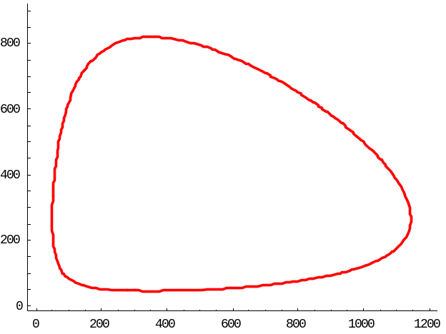

to see the solution curve. To zoom in on the high point on the graph, we enter

ImplicitPlot[eq, {x, 345, 355}, {y,819.85,819.95},
PlotPoints -> 50 ];
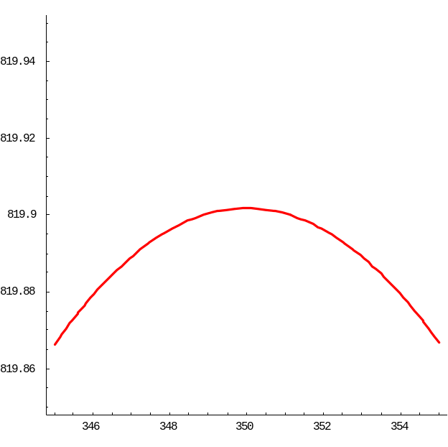

and conclude that the high point has approximate coordinates
Using MATLAB

First we enter the desired parameter values

p := 0.08; q := 0.07;
a := 0.0003; b := 0.0002;
c := 1.87915;

Then we specify the viewing window

x = 0 : 12 : 1200;
y = 0 : 9 : 900;

specifying 100 subintervals in each direction. Next we set up an array of grid points in this window, and calculate the values of the function corresponding to (3) at these grid points.

[x,y] = meshgrid(x,y);
z = (x.^q).*(y.^p) - c*exp(b*x).*exp(a*y);

and our implicit solution equation in the form

z := (x^q)*(y^p) - c*exp(b*x)*exp(a*y);

Then we need only enter the command

contour(x,y,z,[0 0],'r')

to see the solution curve.

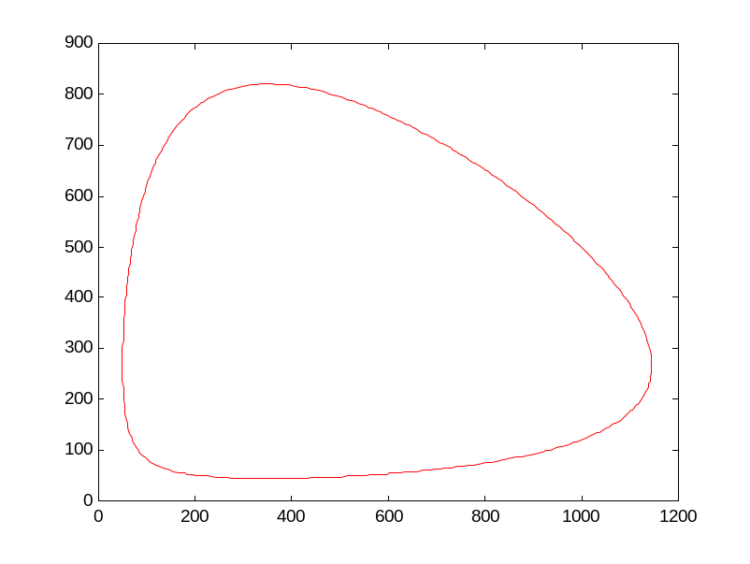

We need only change the viewing window to zoom in on the high point. To zoom in on the high point on the graph, we repeat the commands above with new viewing window

x = 345 : 0.1 : 355;
y = 819.85 : 0.001 : 819.95;
[x,y] = meshgrid(x,y);
z = (x.^q).*(y.^p) - c*exp(b*x).*exp(a*y);
contour(x,y,z,[0 0],'r')

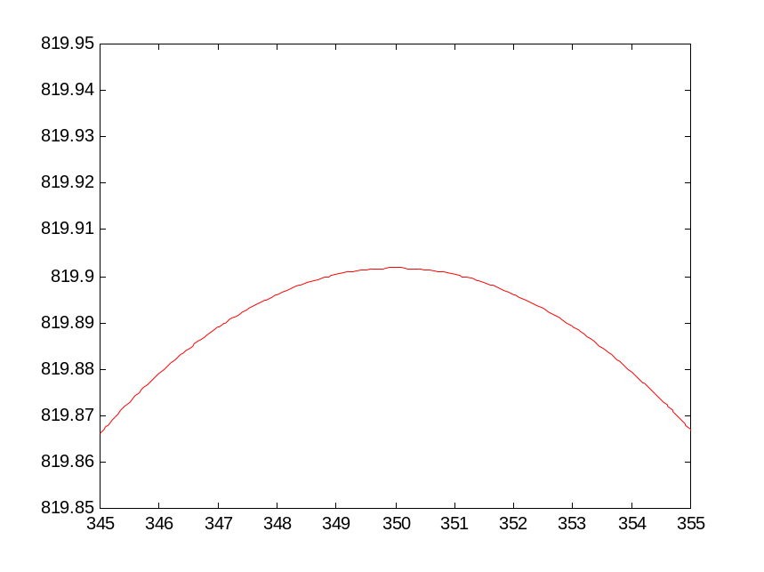

and conclude that the high point has approximate coordinates

